Appendix D

Database

-Manuel-

The following figures are the Conceptual model and the Entity/Relationship (E/R) model of the database that shows an overview of all the information (attributes) stored inside the five different entities: User, loan, account, history, exchange rate. The relationships between them are also represented in the figure, with all the cardinality, primary key and foreign key.

Relationship Model:

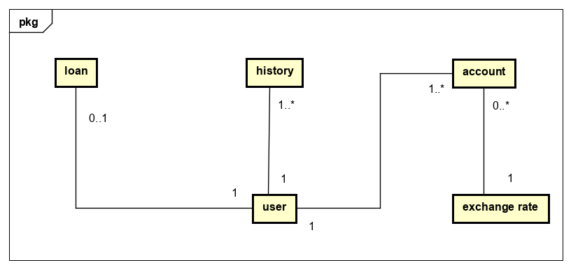

The entity User relates to all other tables by one to many. The database respect 1nf and 2nf.

The first normal form is been respected because each variable has a single value and the entity in a column are the same type and the rows are uniquely identified by a variable.

The second normal form is been respected because all the attributes (non-key columns) depend on the key.

The third normal form is the only one that is not respected because all fields can’t be determinate by the key in the table and no other column.

Conceptual Model: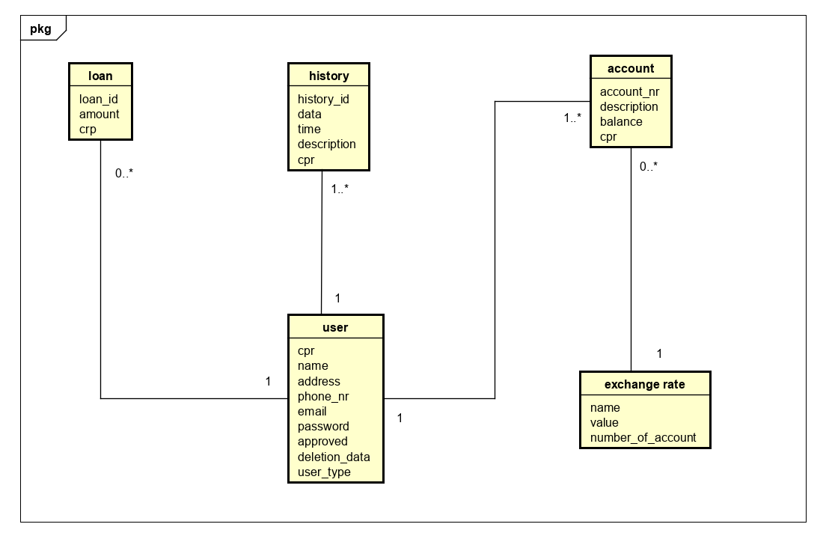

The variable address is kept in user because we don’t use it in our system as a variable that helps the staff and manager with all the information about the customers.

Database Model:

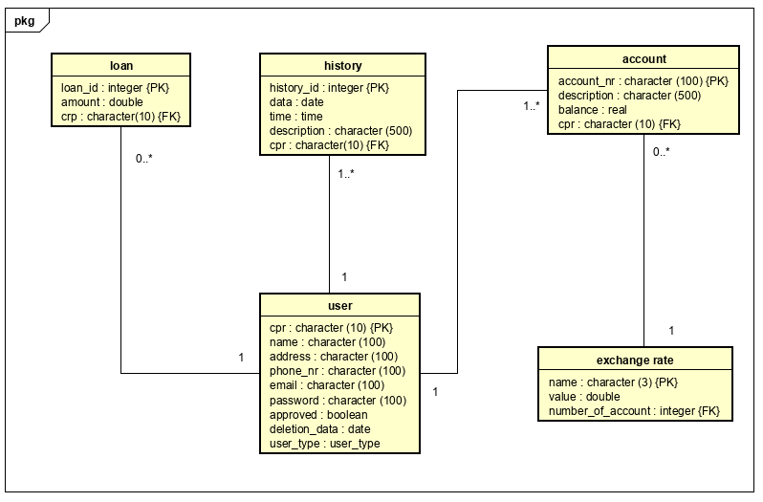

The model was created in the PostgreSQL and implemented in our system.

**SQL code for database creation:**

CREATE DATABASE "BBB-DataBase";

CREATE SCHEMA bbb_dbs;

CREATE TABLE bbb_dbs.user (

    cpr character(10) NOT NULL PRIMARY KEY,

    name character varying(100) NOT NULL,

    address character varying(100) NOT NULL,

    phone_nr character varying(100) NOT NULL,

    email character varying(100) NOT NULL,

    password character varying(100) NOT NULL,

    approve boolean NOT NULL,

    deletion_date date,

    user_type public.user_type NOT NULL

);

CREATE DOMAIN bbb_dbs.user_type AS character varying

CONSTRAINT user_type_check CHECK (((VALUE)::text = ANY ((ARRAY['client'::character varying, 'staff'::character varying, 'manager'::character varying])::text[])));

CREATE TABLE bbb_dbs.account (

    account_nr character varying(100) NOT NULL PRIMARY KEY,

    description character varying(500),

    balance real,

    cpr character(10) NOT NULL,

FOREIGN KEY(cpr) REFERENCES bbb_dbs.user(cpr)

);

CREATE TABLE bbb_dbs.exchange_rate (

    name character(3) NOT NULL PRIMARY KEY,

    value double precision,

    number_of_accounts integer

);

CREATE TABLE bbb_dbs.history (

    history_id integer NOT NULL PRIMARY KEY,

    date date NOT NULL,

    "time" time without time zone NOT NULL,

    description character varying(500) NOT NULL,

    cpr character(10) NOT NULL,

FOREIGN KEY(cpr) REFERENCES bbb_dbs.user(cpr)

);

CREATE TABLE bbb_dbs.loan (

    loan_id integer NOT NULL PRIMARY KEY,

    amount double precision NOT NULL,

    cpr character(10) NOT NULL,

FOREIGN KEY(cpr) REFERENCES bbb_dbs.user(cpr)

);

**DML**

DML code for DataBase interaction

* SELECT * FROM bbb_dbs.user WHERE approve ='false';
* SELECT * FROM bbb_dbs.user WHERE user_type ='staff' OR user_type ='manager';
* SELECT * FROM bbb_dbs.loan;
* UPDATE bbb_dbs.exchange_rate SET number_of_accounts = '12' WHERE name = 'DKK';
* SELECT * FROM bbb_dbs.user;
* INSERT INTO bbb_dbs.exchange_rate VALUES('RUB', '0.09', '0');